Water Level Indicator Project Report

**TABLE OF CONTENTS**

|  |  |  |
| --- | --- | --- |
| ***i.* INTRODUCTION** | | **3** |
| *Li* | PROBLEM STATEMENT | 3 |
| *1.2* | BACKGROUND | 3 |
| *13* | SCOPE | 3 |
| *1.4* | OBJECTIVES... | 4 |
| 1.5 | FUNCTIONAL REQUIREMENTS... | 4 |
| *1.6* | DESIGN CONSIDERATIONS... | 4 |
| *1.7* | POTENTIAL APPLICATIONS... | 4 |

|  |  |  |
| --- | --- | --- |
| *2.* | **APPARATUS...** | **4** |
| *3.* | **PROCEDURE** | **6** |
| ***4.*** | **HARDWARE IMPLEMENATATION** | **7** |
| ***5.*** | **SOFTWARE IMPLEMENTATION** | **9** |
| *6.* | **FUTURE WORK** | **11** |
| z | **CONCLUSION** | **11** |

Page **2** '24'12

Water Level Indicator Project Report

**WATER LEVEL INDICATOR**

**1. INTRODUCTION:**

A water level indicator is a device used to monitor and display the water level in a tank or reservoir. This type of indicator is commonly used in various applications, such as in domestic water tanks. industrial tanks, and agricultural reservoirs. The purpose ofa water level indicator is

to provide a visual indication of the water level, allowing users to monitor and control the amount of water in a particular container.

In digital logic design. a water level indicator can be implemented u electronic circuits and

digital components. The design involves the use of sensors and es to detect the water level.

**1.1._Problem statement:**

Design and implement a digital water level indicator system using digital logic components and microcontroller technology. The objective is to create **a** reliable and accurate system that can monitor and display the water level in a tank or reservoir. The system should be capable of providing real-time information about the water level, and it should be user-friendly with a clear and easily interpretable display.

**1.2. Background:**

Water level monitoring is crucial in various applications, including domestic water tanks, industrial reservoirs, and agricultural irrigation systems. Digital water level indicators play a vital role in water resource management, helping users optimize water usage, prevent overflow or depletion, and enhance overall efficiency. These systems contribute to water conservation efforts and promote sustainable practices.

**1.3. Scope: •**

The Water Level Indicator project is a digital logic system designed to monitor and manage water levels across diverse applications. Primarily developed for educational purposes, it serves as a hands-on tool for learning digital logic design principles. The system's versatility enables it

to monitor multiple locations simultaneously, making it applicable to scenarios such as reservoirs, wells, storage tanks, and environmental monitoring. With features like smart home integration, data logging, and automation potential in agriculture, the project extends beyond basic water level monitoring. Its adaptability to off-grid applications, integration with other systems, and possible contributions to environmental monitoring and disaster relief make it a

Page **3** of **12**

Water Level Indicator Project Report

CamScanner

dynamic project with evolving scope. catering to technological advancements and changing user needs.

**1.4.0bjectives:**

* Design and implement a digital water level indicator circuit using appropriate

logic gates and components.

* Demonstrate a clear understanding ofdigital logic print' es and circuit

design techniques.

* Apply knowledge of sensors. logic gates, and out t devices to create a

functional system.

* Test and verify the accuracy and reliability f the water and indicator.

**1.5. Functional Requirements:**

* Accurately detect and display water levels in a tank or reservoir.
* Indicate multiple water levels using LED's or other visual indicators.
* Integrate with external devices or systems

**1.6. Design Consideration:**

* Selection of appropriate logic gates.
* Power supply and power management consi rations.
* Circuit layout and wiring.
* Testing and calibration procedure.

**1.7. Potential Applications:**

* Home and industrial water tanks
* Irrigation systems
* Sewage treatment plants
* Chemical storage tanks
* Aquarium and fish tanks **2. APPARATUS:**

Building a digital water level indicator with the listed components involves:

Breadboard, resistors, transistors, NOT gate, LED's, Jumper cables, 9V battery with voltage controller.

Page **4 of 12**



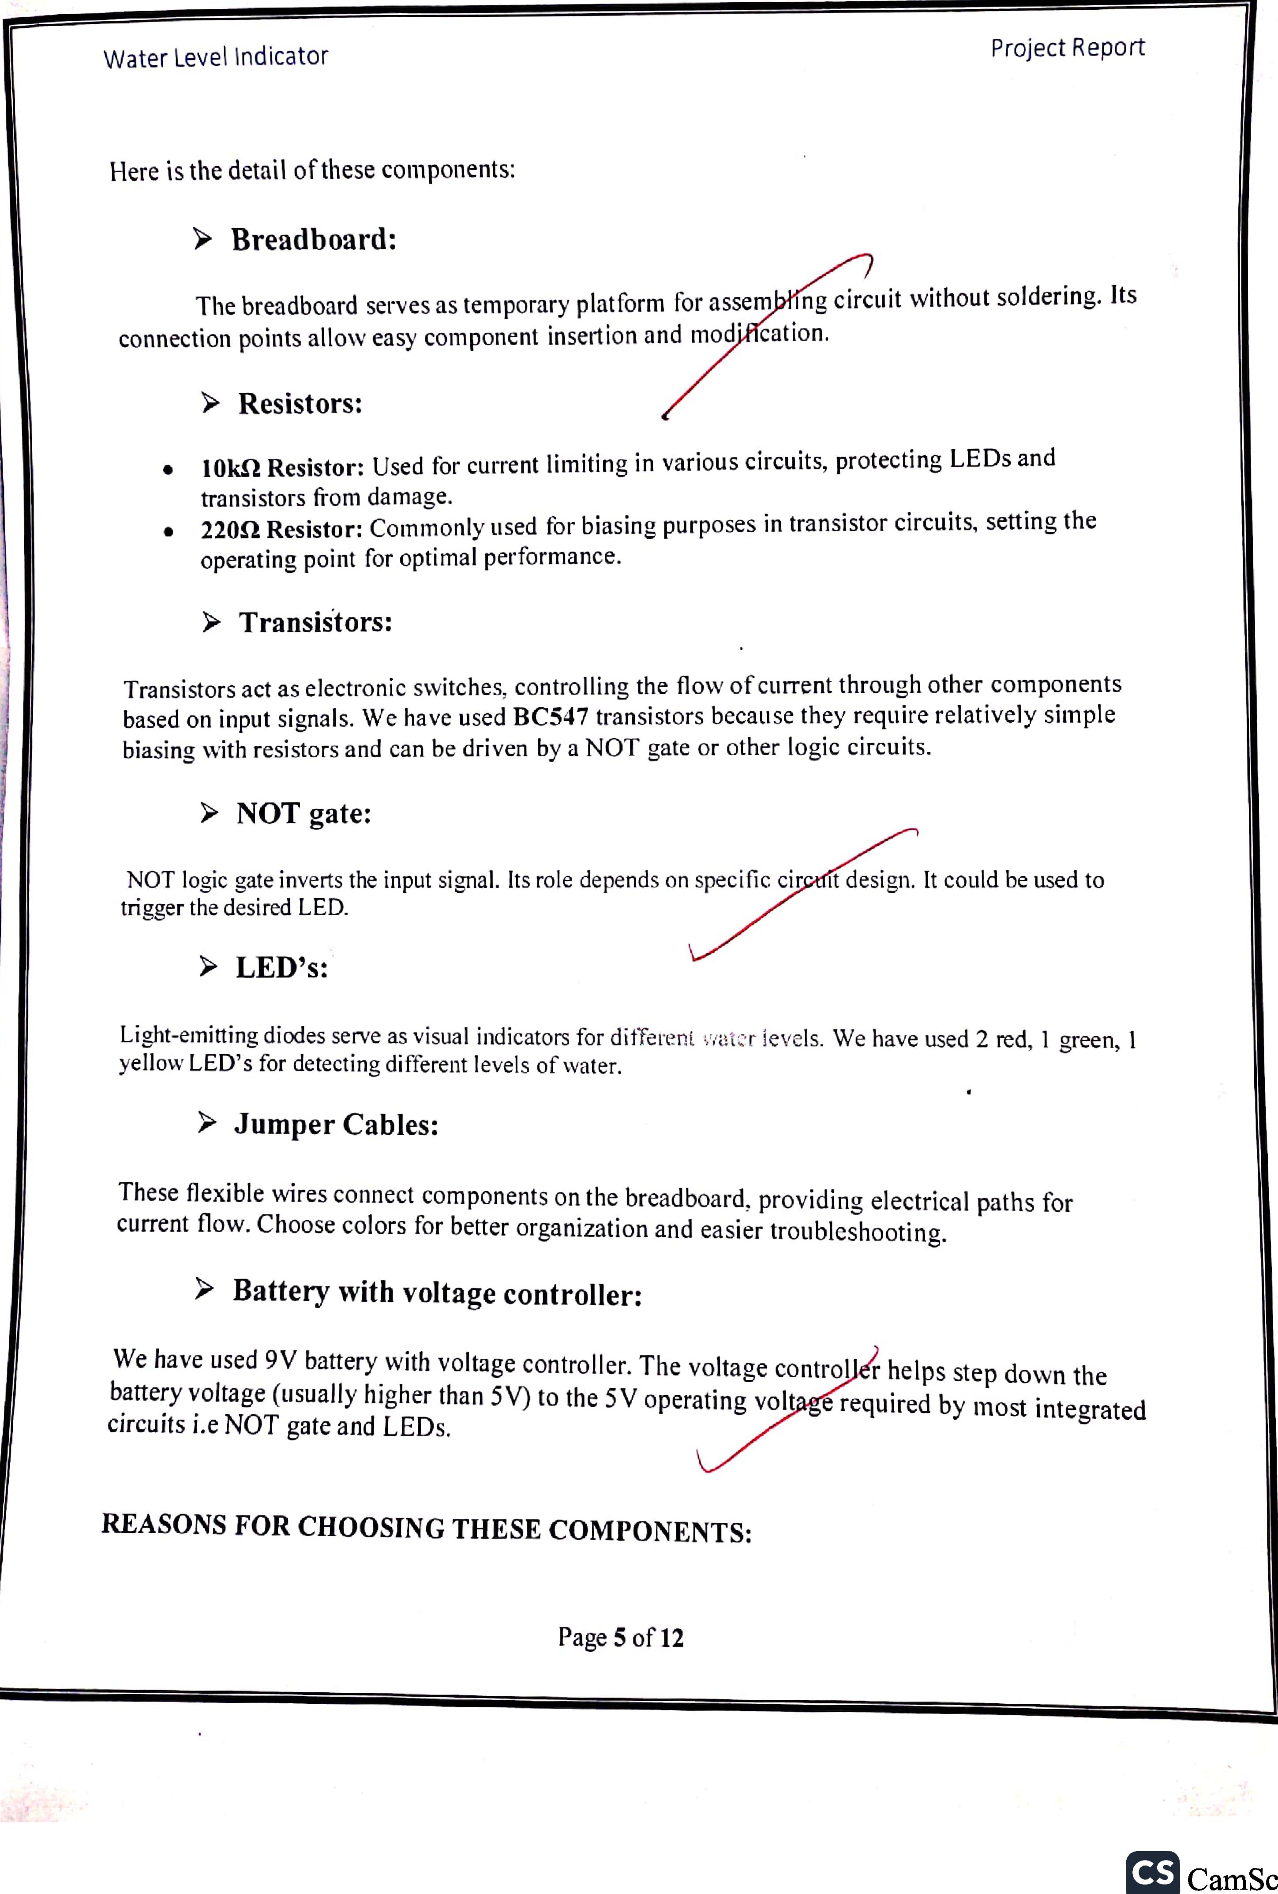

Project Report

Water Level Indicator

Here is the detail of these components:

**> Breadboard:**

The breadboard serves as temporary platform for assem ing circuit without soldering. Its connection points allow easy component insertion and mod* cation.

* **Resistors:**
* **101c11 Resistor:** Used for current limiting in various circuits, protecting LEDs and transistors from damage.
* **22012 Resistor:** Commonly used for biasing purposes in transistor circuits, setting the operating point for optimal performance.
* **Transistors:**

Transistors act as electronic switches, controlling the flow of current through other components based on input signals. We have used **BC547** transistors because they require relatively simple biasing with resistors and can be driven by a NOT gate or other logic circuits.

* **NOT gate:**

NOT logic gate inverts the input signal. Its role depends on specific cir it design. It could be used to trigger the desired LED.

* **LED's:**

Licht-emitting diodes serve as visual indicators for different ,,vai:;r levels. We have used 2 red, 1 green, **1** yellow LED's for detecting different levels of water.

* **Jumper Cables:**

These flexible wires connect components on the breadboard, providing electrical paths for current flow. Choose colors for better organization and easier troubleshooting.

* **Battery with voltage controller:** We have used 9V battery with voltage controller. The voltage control ir helps step down the

battery voltage (usually higher than 5V) to the 5V operating volt e required by most integrated circuits i.e NOT gate and LEDs.

**REASONS FOR CHOOSING THESE COMPONENTS:**

Page **5** of **12**